THE NATIONAL ASSOCIATION OF GRADUATE-PROFESSIONAL STUDENTS

Legislative Letters
January 20th, 2021
Subscribe

Updates in Higher Education

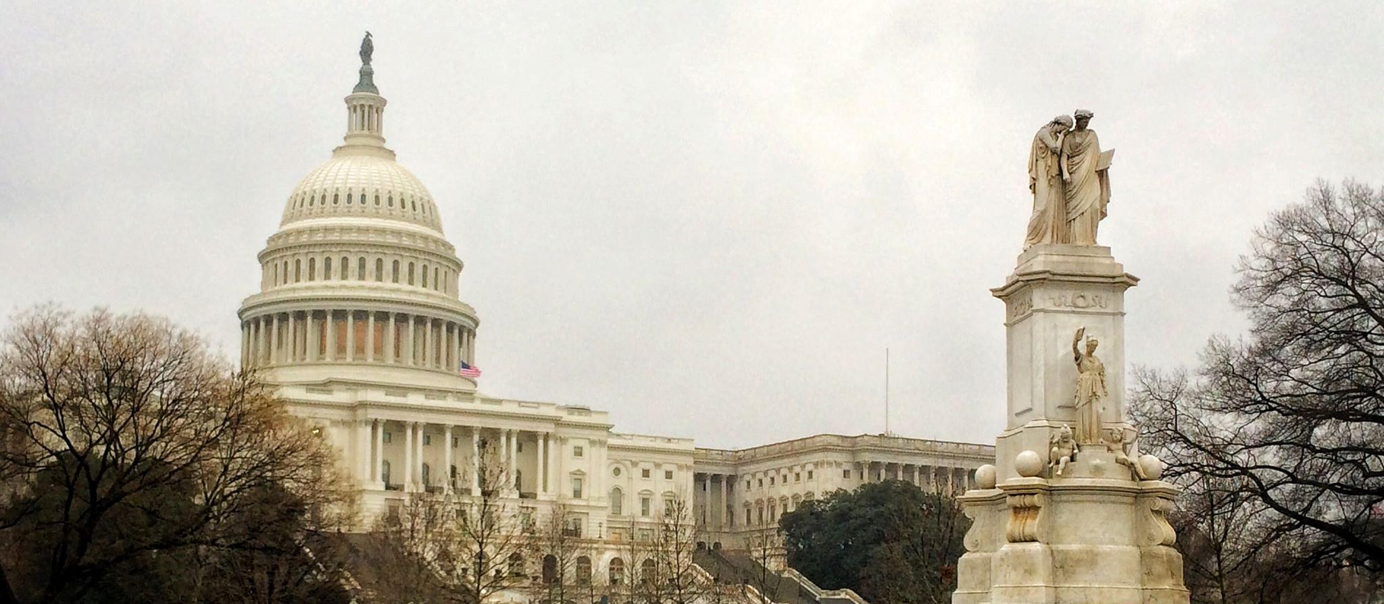
Image Credit: Kaylynne Glover, “The Capitol”

After multiple encounters with a government shutdown close to Christmas, both COVID relief packages as well as appropriations for FY 2021 were passed and signed. The Biden administration is off to a running start with more than 50 executive orders planned for the next 10 days, and a long list to accomplish in the first 100. With the new administration in, DACA may seem on firmer ground, though legal battles surrounding it continue. Also in the courts is a case regarding the ability of Universities to regulate off-campus speech.

THE EXECUTIVE BRANCH

THE WHITE HOUSE AND OTHER AGENCIES

Earlier today, Joe Biden Was sworn in as the 46th president of the United States. He is expected to set out 53 executive orders over the next 10 days, reversing many Trump-era policies and reinforcing some from the Obama administration. The rollout of these orders will be divided by issue each day; today will be focused around “four crises” currently facing the country: coronavirus, climate change, the economy, and equity. Higher education issues will likely be spread out over the next several days, but here are a few which are currently expected: expanding the usability of Pell Grants, a review of the public charge rule, extending rental assistance as well as a moratorium on evictions and foreclosures, and instructing the Department of Education to extend student loan forbearance until September.

THE DEPARTMENT OF EDUCATION

Secretary of Education Betsy DeVos tendered her letter of resignation to then-President Trump on January 7th, citing her belief that “we each have a moral obligation to exercise good judgement and model the behavior we hope they [children] would emulate.” During her tenure, DeVos oversaw the reversal of several Obama-era policies, including guidance on “discriminatory discipline” and transgender students. She advocated for spending cuts prior to the pandemic, and clashed with states regarding the use of CARES act funding. Deputy Mick Zais served in her place up to the transition with the Biden administration.

President Biden has formally selected Miguel Cardona to be the secretary of education for the incoming administration. Cardona has been serving as the Connecticut commissioner of education since 2019. Biden touted Cardona’s service during the pandemic, stating that “He is a secretary of education for this moment” and that “we need someone who knows what it’s like, what it takes to get through this crisis.” This nomination follows through on Biden’s promise to nominate a former educator to the position. The president-elect has also pledged to reopen schools within his first 100 days as president, a commitment that Cardona seems poised to act on. In a statement submitted on December 23rd, Cardona discussed his passion for public education, but has remained relatively silent on higher education. With his background being in primary and secondary education, Robert Shireman, former deputy undersecretary of Education under President Obama, had this to say regarding the nomination: “If Cardona is the pick, it underscores the need for a deputy role that will focus on higher education and especially financial aid and student loans.”

IMMIGRATION AND INTERNATIONAL STUDENT CONCERNS

On January 8th, the Department of Homeland security issued new H1-B Visa Rules, which does away with the lottery system, opting instead to grant petitions based on the applicant’s salary. NAGPS has issued a statement against this rule, available here. The rules will go into effect in 60 days, barring an intervention by the Biden administration or lawsuit. If implemented, these rules will lower an already decreasing international student enrollment in American universities.

THE LEGISLATIVE BRANCH

LEGISLATION

After significant debate, and on the brink of a government shutdown, both the COVID Relief Package and the FY2021 Omnibus Appropriations were signed in on December 27th. Lets take a look at some of the measures which were included, starting with COVID relief.

An $82 Billion Education stabilization fund was established which will remain active until October 2022. $22.7 billion of this was allocated for Higher Education, $20.2 billion of which will be dispersed to institutions based on student full-time enrollment. Institutions will be able to use these funds to cover lost revenue, reimburse expenses, technology costs for virtual learning, as well as financial aid for students. It also comes with a maintenance of effort clause which requires states to fund K-12 and higher education proportionally to the past 3 years, based on their overall spending.

The Omnibus secures federal agency operations through September. Some of the allocations include: $73.5 billion for the Education Department (a 1.2% increase), $8.48 billion for the National Science Foundation (a 2.5% increase), $42.9 billion for the NIH (a 2.3% increase), $40 billion for the Department of Energy (a 2.5% increase) and $9.2 billion for the EPA ( a 2% increase). Legislative add-ons of note include: a simplification of the FAFSA application, an expansion of Pell Grant eligibility and award amount, ensuring equitable distribution of grant awards from federal agencies, and calling for a program to award 2-year postdocs through the NSF for researchers whose employment may have been impacted by COVID-19.

THE JUDICIAL BRANCH

THE SUPREME COURT

On January 8th, the supreme court agreed to hear a major case on campus speech. The question of the case is “whether Tinker v. Des Moines Independent Community School District, which holds that public school officials may regulate speech that would materially and substantially disrupt the work and discipline of the school, applies to student speech that occurs off campus”. The 3rd circuit court of appeals previously ruled in favor of the student, stating that “public schools have an interest in teaching civility… they may not leverage the coercive power with which they have been entrusted to do so.”

LITIGATION

Legal battles surrounding the renewed implementation of the DACA program continue, as a coalition of 9 states sought to invalidate the program in federal court. Though the supreme court did not rule on the legality of the DACA program, it has overturned the Trump administration efforts to end the program, citing them as “arbitrary and capricious”.

On December 23rd, the 9th circuit court issued a preliminary injuction stopping the enforcement of executive order 13950, which prohibits federal contractors and subcontractors from using “any workplace training that inculcates in its employees any form of race or sex stereotyping or any form of race or sex scapegoating”, including a list of “divisive concepts.” It was ruled that this order violated the first amendment’s free speech clause as well as the due process clause of the fifth ammendment, as it “impermissibly chills the exercise of...protected speech”, and “it is impossible for Plaintiffs to determine what conduct is prohibited.”

IN RELATED NEWS…

RELEVANT READS

Diversity, Inclusion, and Social Justice
Loan Forgiveness for HBCU’s

Graduate School and Campus Climate

Are colleges superspreaders?
Stress and the pandemic
A pivotal year for pre-prints

The State of Higher Education

What the SolarWinds hack means for Higher Education
Outcomes for Graduates during recession
Interview with the writers of The New PhD.: How to Build a Better Graduate Education

Career Advice
“How to know a sinking ship when you see one”

Higher Education Policy

Higher Education workers may be next for the vaccine
Live updates on Biden’s Higher Education Policy

